**WHAT IS WHISPER**

Module Used to convert audio to text transcript

**NLP TASKS**

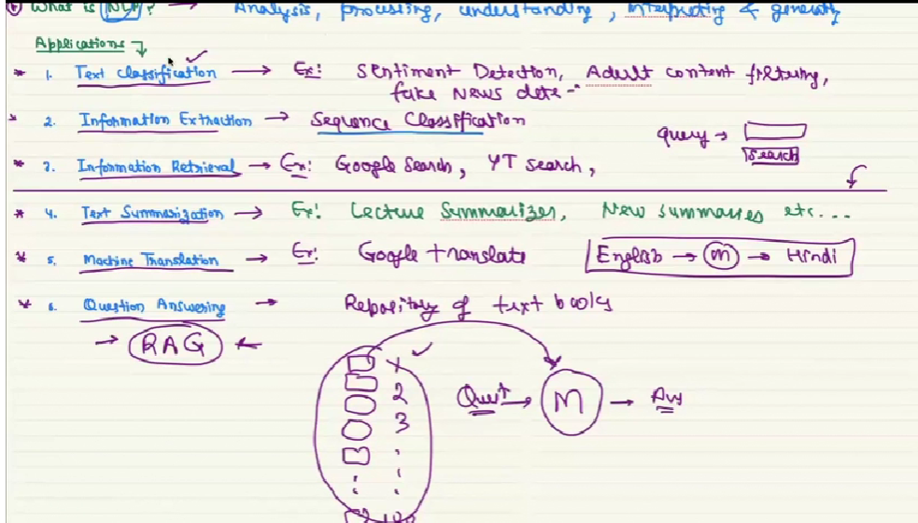

**WHAT IS HUGGING FACE**

It is a free open source framework that helps allows user to download large language model on system and with that we can develop model in local system, while Open AI and gemini has very larger downloadable size of LLMS.

All the NLP tasks can be easily doable by this.

Not only nlp tasks it can did various image processing, object detection etc. All the task that can be done by hugging face are listed here.

[Tasks - Hugging Face](https://huggingface.co/tasks)

**Installing hugging face**

Hugging face can be installed by installing all below three libraries.

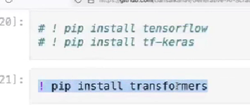



**Example code on hugging face:**

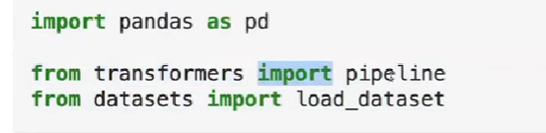

With the pipeline we have to NLP tasks. Below Is the example for text-classification(we take whole paragraph and classify it’s type).

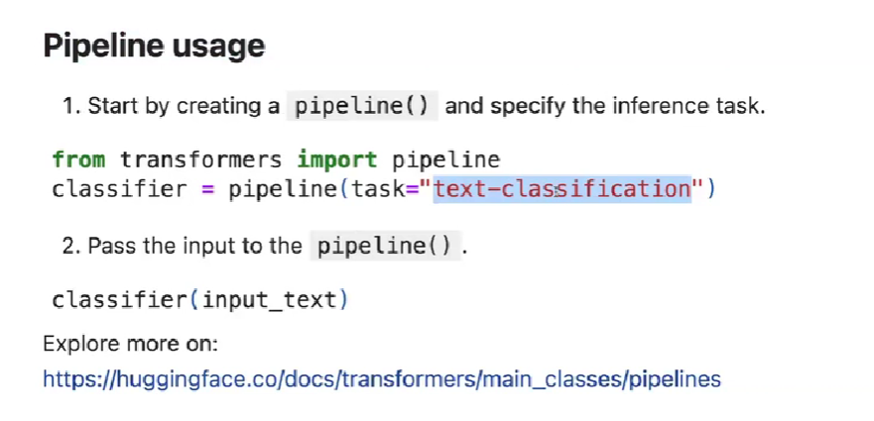

**SENTIMENT ANALYSIS EXAMPLE**

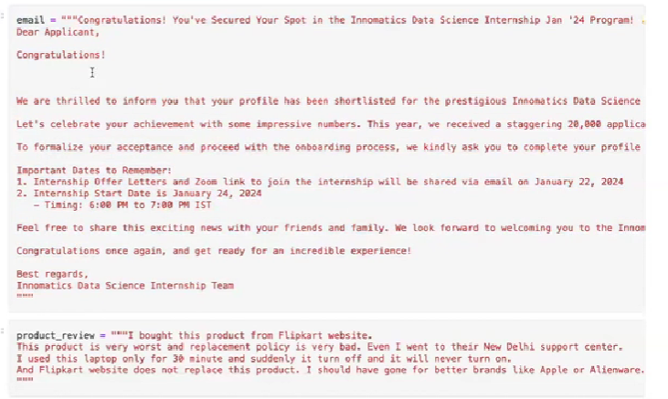

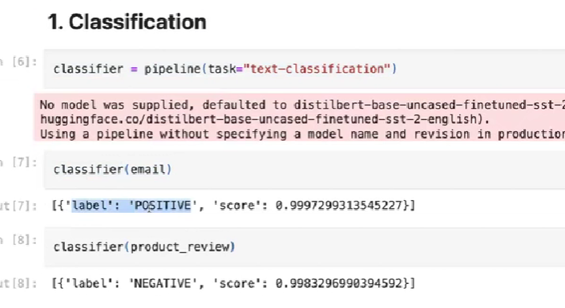

**INFORMATION EXTRACTION EXAMPLE**

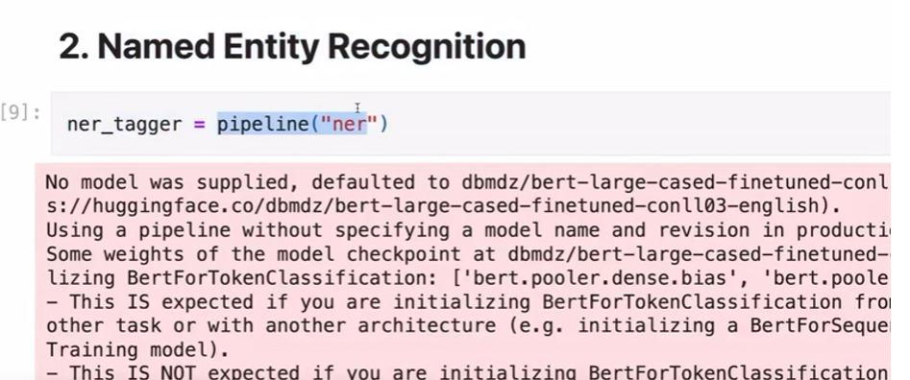

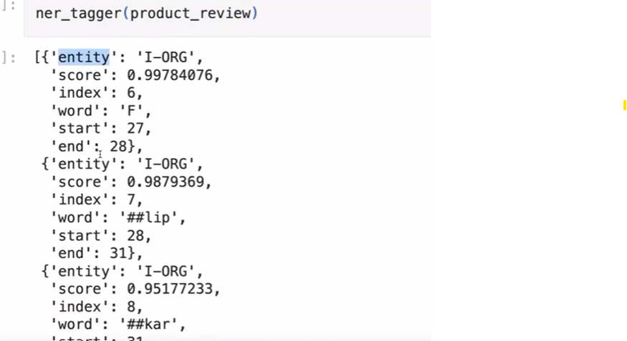

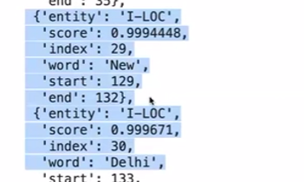

In the above example it extractes information by looking each and every letter of a word ORG meand a word related to organization, LOC means a word related to location.

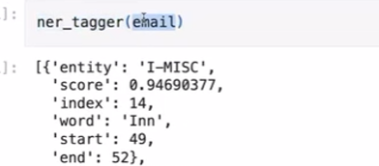

In some word which it can’t recognize it will give it is MISC

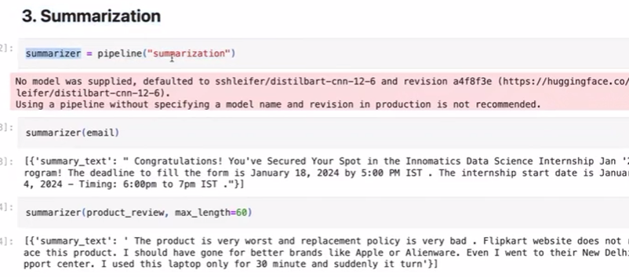

**4. Question answering system in hugging face**

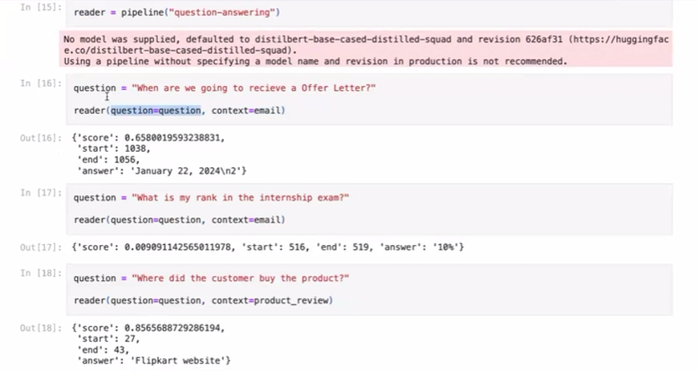

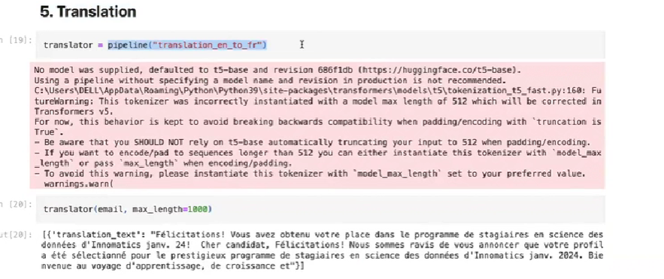

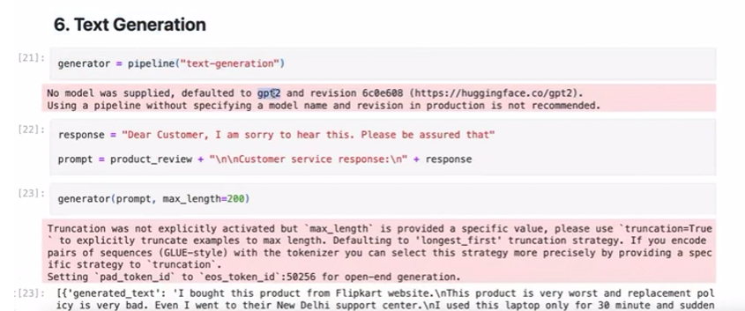

**With hugging face we can use do image classification**

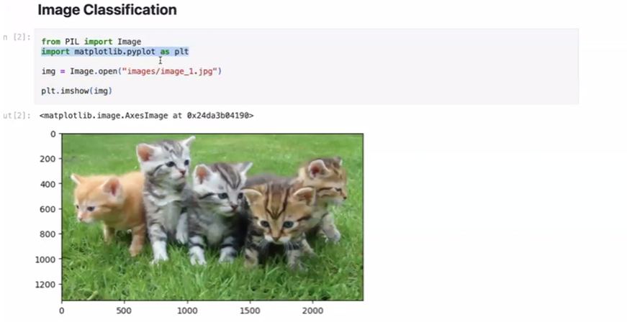

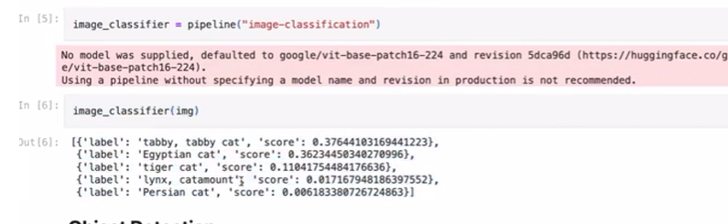

And we can detect objects too

